

|  |  |
| --- | --- |
| **Final Project Report**  Interaction Technology Utrecht University, october 2013  **Team**  Rutger Kerkhoff (3675300) Daan Rijpkema (3863174) | Table of Contents   * Introduction * Deliverables & Notes * Description * Appendix: project proposal |

# Introduction

When you managing a public space or a room on a daily basis, it can be useful to gather data and statistics about the usage of that space. You can measure the level of activity over time and the amount of people in the space or create a heatmap with levels of activity for each part of the room. With this information, you can then conclude if the space is effectively arranged and is able to handle the influx of ‘users’. Creating a system that measures the presence and movement of human beings (without identifying them) could yield interesting data for use in safety (warn room supervisors if it gets too full) but also in entertainment (adaptive music) or in social studies (when does a room fill up, do people gather often, etc.). This is **Cameo**.

**More information and documentation, next to this document, can be found on** [**http://www.daanrijpkema.com/cameo**](http://www.daanrijpkema.com/cameo)

# Deliverables & Notes

In this package you will find:

* The source code for Cameo, written in C# using the Kinect Libraries.
* This readme/project document
* A built version of the software

**Note**: Make sure to have connected the Kinect hardware and also have installed the accompanying drivers. Without it the program will notify you about this and you will not be able to use it completely.  
Also make sure to have the Kinect SDK installed before trying to run this program via Visual Studio.

# Description & Features

* Cameo: gaining and analysing all data from the Kinect hardware|

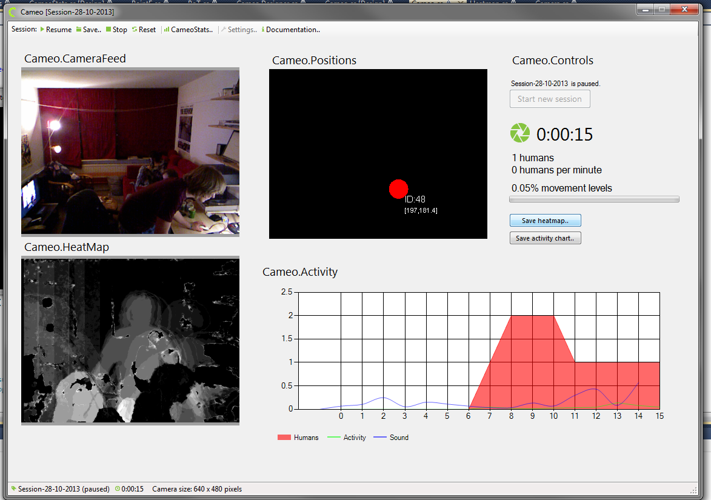

* CameoStats: reading of Cameo files to display statistics generated through Cameo

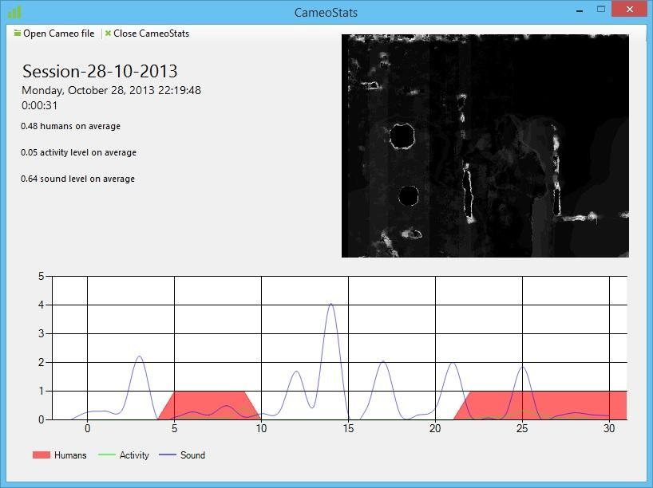

# Appendix: project proposal

Interaction-technology : Project Proposal

**Team**

* Rutger Kerkhoff (3675300)
* Daan Rijpkema (3863174)

**Concept**See introduction

**Possible application spaces**

* student/study associations
* home for the elderly
* hospitals
* schools
* libraries
* bars/clubs/lounges
* public and private spaces, i.e. airports, train stations, bus stops, police stations, jails, offices

**Uses and application features**

* Heatmap of activity within the space
* Activity over time and measured against amount of people
* Relation of spatial activity with sound (pitch, volume, tempo)
* Mood analysis of the space’s residents
* Gender demography and statistics
* Predictions and long-term statistics about the space.
* Control and adjust atmosphere (lighting and sound/music) according to the amount of people/activity.

**Used interaction technologies**

* Pixel Image detection, motion detection
* Sound recording

**Brainstorm**

See diagram below.

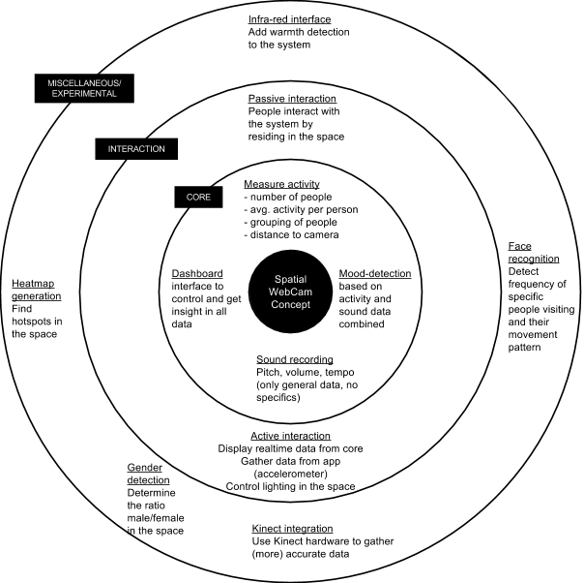

**Implementation Plan**

* Install webcam with view on spatial environment
* Install one or more microphones that record basic sound data
* Create software that analyses webcam and microphone(s) feed real-time
  + Analyse pixel images: distill activity levels and number of people
  + Analyse sound data: distill pitch, tempo and volume levels
  + Analyse gathered data in relation to each other: determine ‘mood’ level via (learning) algorithm
* Create dashboard that displays raw and processed data and allows customization

**Examples**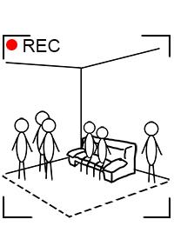

1. Camera feed

The software will use the camera feed to determine the amount of people in a room and where they are and their activity levels.

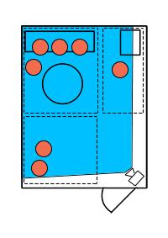

1. Generated Heatmap

We can then generate a heatmap showing where every person in the room is. By dividing the room in different areas, we can determine hotspots and use that knowledge to our advantage.

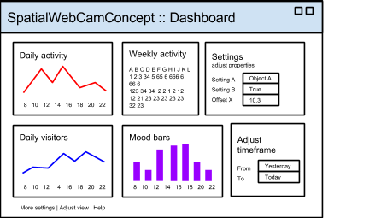

1. Dashboard Interface

Concept of the user interface of the web-based dashboard where all the data is visualized and all algorithms are controlled. It functions in a similar fashion as Google Analytics or any comparable system where data and graphs are the main content.

**Notes**

* We can possibly use a Kinect or similar motion detector to implement more accurate motion detection in our system, rather than writing partially from scratch (using libraries like EmguCV).